SBA MEMBERSHIP RENEWAL FORM

NAME:__________________________________________ PHONE:___________________________
ADDRESS:____________________________________________________ TOWN:___________________________
PROVINCE:________ POSTAL CODE:________________
EMAIL:__________________________________ NEW:_______ RENEWAL:_______

Circle Applicable Membership Option Below:
 | Junior (under 18) | Individual | Couple (2 Adults) | Family (Up to 2 Adults, Children under 18) | Lifetime
1 Year | $15 | $40.00 | $50.00 | $60.00 | $500.00
3 Years | $45 | $100.00 | $120.00 | $160.00
5 Years | $75 | $160.00 | $180.00 | $260.00

List Family Members and Date of Birth for any children:

__________________________________________________________________________________________________

__________________________________________________________________________________________________

RETURN TO:

Kyle Wagner
29 Whisper River Lane
Whisper River Estates, SK S7P 0E5

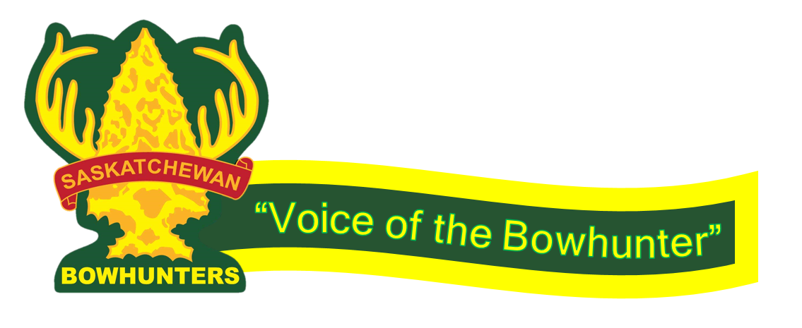
Your membership helps strengthen our voice when promoting bowhunting opportunities at the Wildlife Advisory Committee and with government officials. Thank you for your support!

Renew Online at www.saskbowhunters.ca

